Final result of thematic composing tourney on occasion of the 23rd International Solving Championship of Slovakia. (Bytča 11.-12.4.2015 )
I chose a very old and famous theme Carousel - white queen in all four corners of the chess-board as the theme of this year's composing tourney. My assumptions were filled that some authors put together the prescribed theme with new ideas. Many compositions contained a combination with themes of keys or threats paradoxes, with changes of mates/defenses or twins. What greatly improved the quality of the composition.
But now specifically. From competition organizer Marek Kolčák I got 27 anonymous diagrams + three compositions from very young, 11 year old serbian author whom I appreciated separately. After the initial control, I had to exclude composition which did not meet the theme. The otherwise in excellent composition no.11 the same white queen is not in all corners (at the square a8 enters second queen - promoted queen). After weighing all the pros and cons, I established the following order:

1.prize, composition no.10 Miroslav Kasár ( Slovakia )
Unusual mirroring of position around d and e columns created a double reciprocal change of mates, always two from half defense.
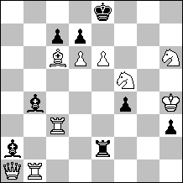
2# (9+8)
B: mirror according to axis between columns d and e

1.Rg3! ~ 2.Qh8#, Rg8#

1...Rg2 a 2.Qh8# A
1...Bxd6 b 2.Rb8# B
1...Rb2 c 2.Rg8# C
1...Bxe6 d 2.Qa8# D

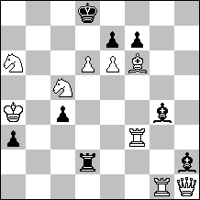

1.Rb3! ~ 2.Qa8#, Rb8#

1...Rg2 a 2.Rb8# B
1...Bxd6 b 2.Qh8# A
1...Rb2 c 2.Qa8# D
1...Bxe6 d 2.Rg8# C

2.prize, composition no.18 Srečko Radović ( Serbia )
Multiphase change of mates and defenses in three positions. Incomplete star of black king. Air position. The form of consistent creation of positions facilitates the work of the author and generates an preconditions to growth of themes.
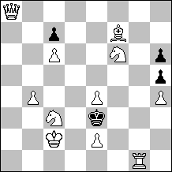
2# (11+4)

B: from A - Sf7 move to c4
C: from B - Da8 move to h1

A:
1.Qh8? zz
1... Kd4 2.Sg4#
1...Kf4 2.Sfd5#
1...Kf2!
1.Qg8? zz

1...Kf4 2.Qg3#
1...Kf2 2.Qg3#
1...Kd4!

1.Sd7? zz

1...Kd4 2.Qa7#
1...Kf2 2.Qa7#
1...Kf4!

1.Qa1 ! zz
1...Kd4 2.Qa7#
1...Kf2 2.Qa7#
1...Kf4 2.Scd5 #

B:
1.Qa1? zz

1...Kd4!

1.Qf8! zz

1... Kd4 2.Qc5#
1...Kf4 2.Sg4#
1...Kf2 2.Qc5#

C:
1.e5! zz

1... Kd4 2.Qe4#
1...Kf4 2.Qe4#
1...Kf2 2.Sc1#

3.prize, composition no.28 Vasil Djačuk ( Ukraine )
Double pseudo le Grand, Hannelius in form of defenses, in this case change of mates are supplemented by the anti-dual motives.

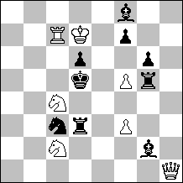
2# (7+9)

1.Qh8? ~.2.Sb6#, Sb4# AB

1...Bg7 2.Qa8# C
1...f6 2.Qg8#
1...Rxf3 2.Qd4#
1...Bxf3!

1.Qe1? ~ 2.Sb6#

1...Sa4 a 2.Qe4#
1...Se2 2.Qa5#
1...Re3!

1.Qh4? ~ 2.Sb4#

1..Sa2 b 2.Qe4#
1...Rg4!

1.Qa1! ~ 2.Qa8 C
1...Sa4 a 2.Sb4# B
1...Sa2 b 2.Sb6# A

1.honourable mention, composition no.29 Vasil Djačuk & Valerij Kopyl ( Ukraine )
Again pseudo le Grand - in this case a cyclic four-phase. The theme is presented very clearly.
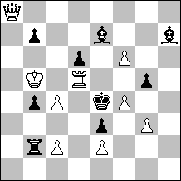
2# (9+9)

1.Qa1? ~ 2.Qh1# A

1...Rb1 2.Qd4# B
1...gxf4!

1.Qa7? ~ 2.Qd4# B

1...b6 2.Qxe7# C
1...Bxf6!

1.Dxb7? ~ 2.Dxe7# C

1...Be~ 2.Qxh7# D
1...Bf5 2.Rxd6#
1...Bg8!

1.Qh8! ~ 2.Qxh7# D
1...Bh~ 2.Qh1# A

2.honourable mention, composition no.25 Dragan Stojnić ( Serbia )
The change of the defenses in the form Meredith.
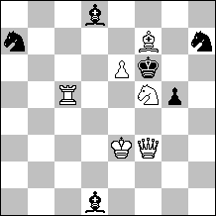
2# (6+6)

1.Qa8? hr. 2.Qxd8#

1...B8~ 2.Qh8#
1...Sc8 2.Qa1#
1...Sc6!

1.Qh1! ~ 2.Qh6#

1...Sf8 2.Qh8#
1...Bh5 2.Qa1#

3.honourable mention, composition no.19 Valerij Kopyl ( Ukraine )
Another pseudo le Grand - now cyclic three-phase.

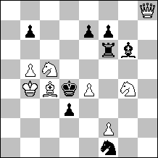
2# (8+8)

1.f3? ~ 2.Sb3# A

1...Sd2! a

1.Qh1! ~ 2.Sb3# A

1...Sd2 a 2.Qa1# B
1...Rf3!

1.Qa8? ~ 2.Qa1# B

1...Rxf2 2.Qd8# C
1...Ra6!

1.Be6! ~ 2.Qd8# C

1...Bxe4 2.Sb3# A
1...Se3 2.fxe3#

1.commendation, composition no.30 Dragan Stojnič and Branislav Djurašević ( Serbia )
Themes Bannyj and Barnes again in the form Meredith.
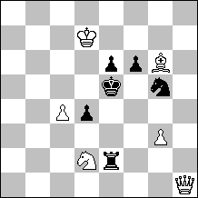
2# (6+6)

1.Qa1? A ~ 2.Qa5# C
1...Se4 2.Sf3#
1...f5! a

1.Qh8? B ~ 2.Qb8# D
1...Se4, Sf7 2.Sf3#
1...d3! b

1.Qa8! ~ 2.Qa5#, Qb8# CD
1...d3 b 2.Qa1# A
1...f5 a 2.Qh8# B
1...Se4 2.Sf3#
2.commendation, composition no.9 Emil Klemanič ( Slovakia )
Theme Hannelius and change of the defenses. Meredith.
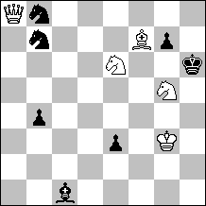
2# (5+7)

1...Sd8 a 2.Qh1# A
1...Sc6 b 2.Qh8# B

1.Qxb7? ~ 2.Qh1# A
1...Sc6! b

1.Qxb8? ~ 2.Qh8# B
1...Sd8! a

1.Qa1! ~ 2.Qxg7#
1...Bb2 2.Qh1#
1...g6 2.Qh8#

3.commendation, composition no.23 Marek Kolčák ( Slovakia )
Theme Dombrovskis. One of the few compositions where the queen in the diagram position is not in one of the corners.
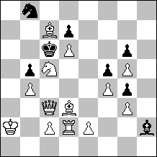
2# (13+7)

1.Qa3? ~ 2.Qa8# A

1...Kd5 2.Bxb5#
1...Sa6! a

1.Qa1? ~ 2.Qh1# B
1...Kd5 2.Bxb5#
1...Bg1! b

1.Qh8! zz
1...Sa6 a 2.Qa8# A
1...Bg1 b 2.Qh1# B
1...Bxg3 2.Qh1#
1...Kd5 2.Bxb5#

4.commendation, composition no.2 Zoltán Labai ( Slovakia )
Theme Dombrovskis with enlargement about change of mates and defense.
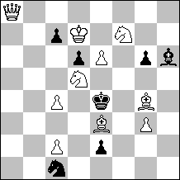
2# (10+7)

1.Bf2? ~ 2.Sc3# A, Sf6# B
1...Be3! a

1.Qh8? ~ 2.Qd4#
1...Bxe3 2.Sc3# A (2.Sf6?)
1...Bg7 2.Qh1#
1...Sb3!

1.Qa1! ~ 2.Qd4#
1...Bxe3 2.Sf6# B (2.Sc3?)
1...Bg7 2.Sg5#
1...Sb3 2.Qh1#
1...c5 2.Sxd6#

Special commendation for the youngest participant of competition, composition no.20 Ilja Serafimovic (Serbia)
The reciprocal change of key and variant mate is good performance in 11 years. Meredith.
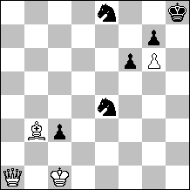
2# (4+6)
B: Qa1 exchange with Kh8

A:
1.Qa8! hr. 2.Qxe8#

1...S4d6 2.Qh1#

B:
1.Qh1! hr. 2.Kc2#

1...Sd2, Sf2, Sg3 2.Qa8#

I want to thank all participants for sending the nice compositions and I congratulate the winners.
Košice: 10.4.2015 Oto Mihalčo, judge

